void setup() {

Serial.begin(9600);

}

void loop() {

Serial.print("Hello there");

}

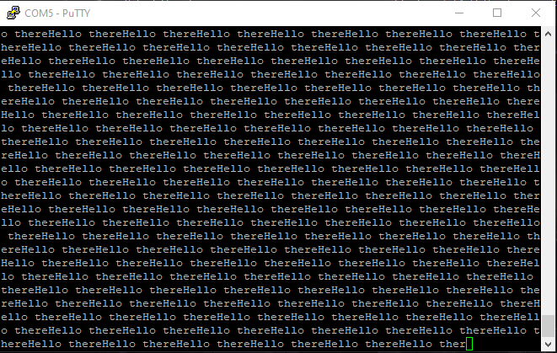

<https://github.com/Bardi03/Seriell-kommunikasjon>